**West Chat BOT**

* **Steps for creating QnAmaker services(**[**https://qnamaker.ai**](https://qnamaker.ai)**) :**
* Add URLs of FAQ in QnA maker services :

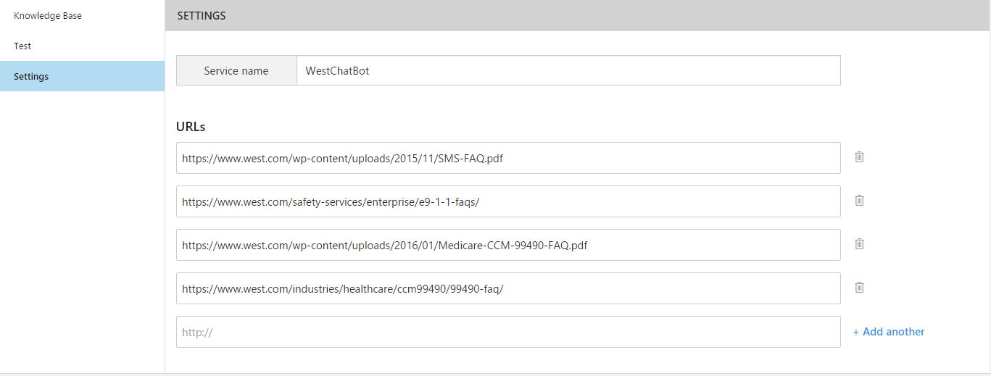

* After train and publish QnA service we can test it :
* We can add alternatives for each questions and again retrain it and publish it.
* Highlighted is one that's already picked and we can change if we want.
* We can download Chat logs from here.

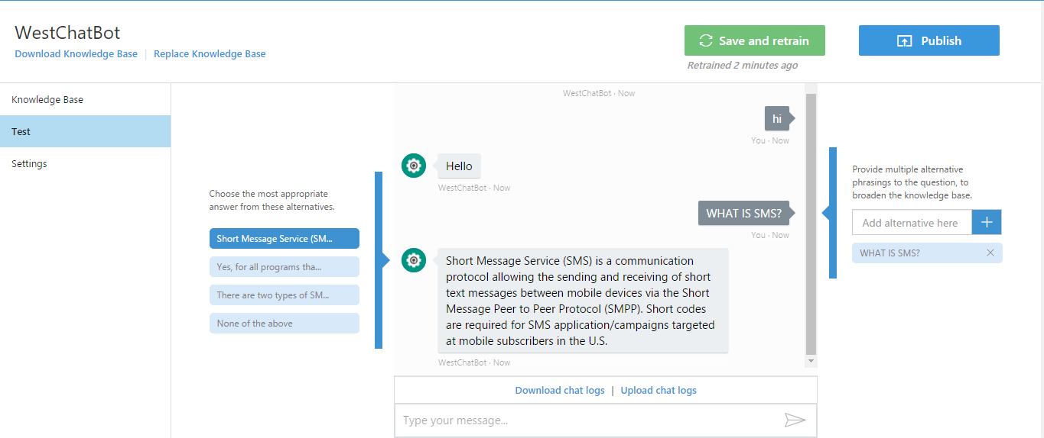

* Generate knowledgebase Key and Subscription key :
* Use this keys in our BOT application to connect with QnAmaker service.

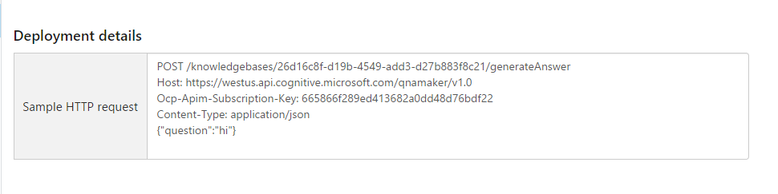

* **BOT Application C# coding** :
* QnAresult class to get json response :

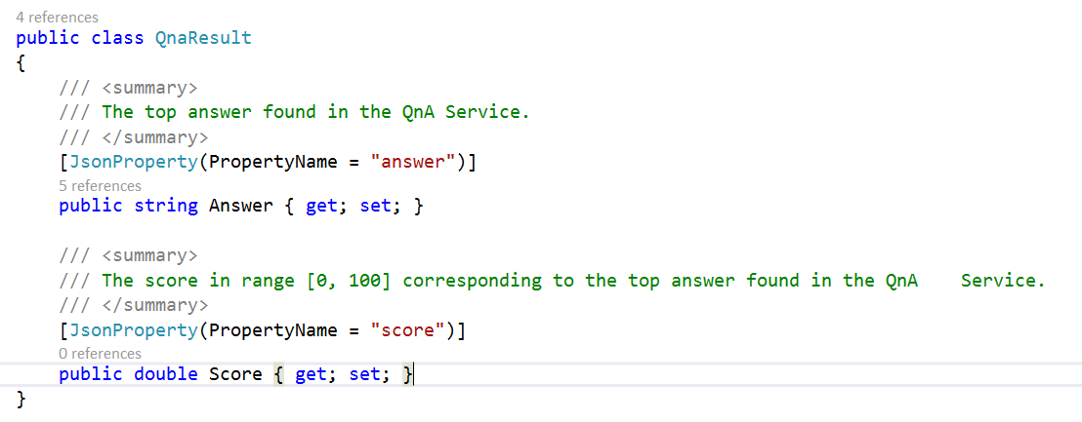

* Getting response based on user FAQ :

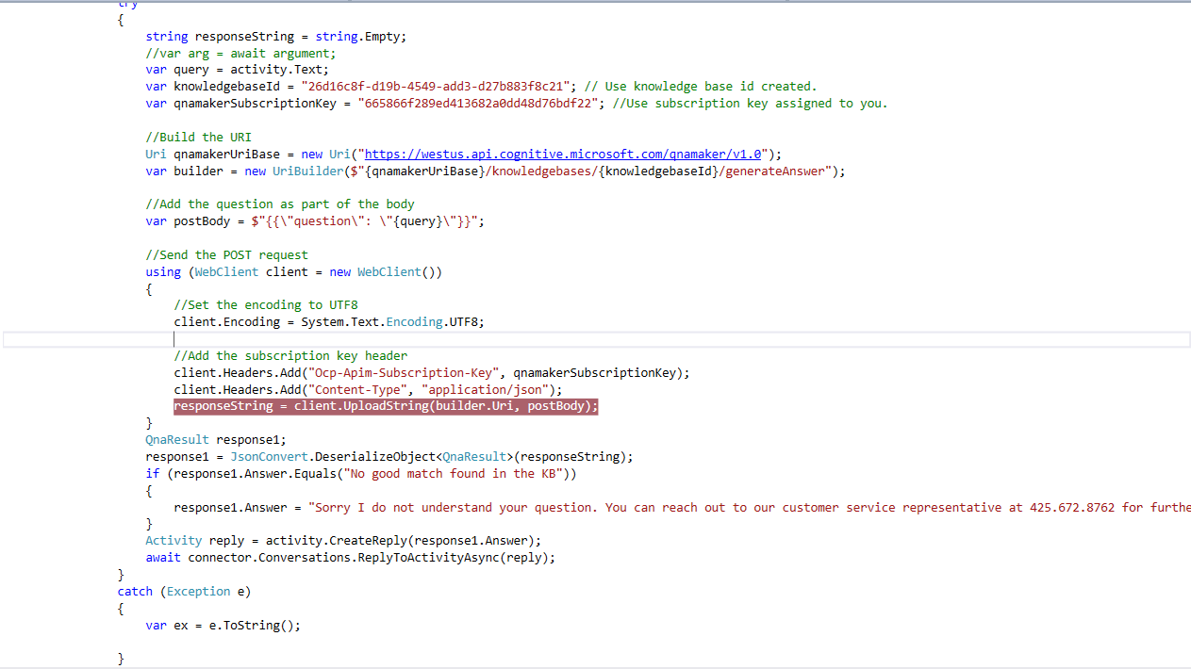

* **Steps for publishing BOT application on Azurewebsites :**
* Right click on solution and select publish.

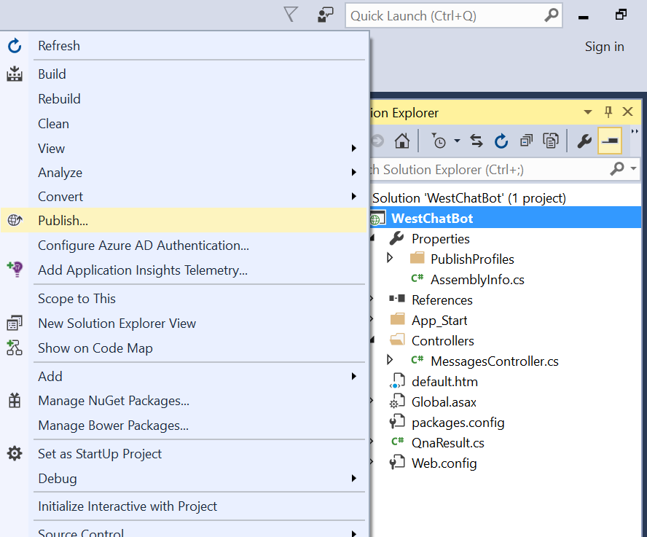

* Select Azure App Service from Publish dialog.

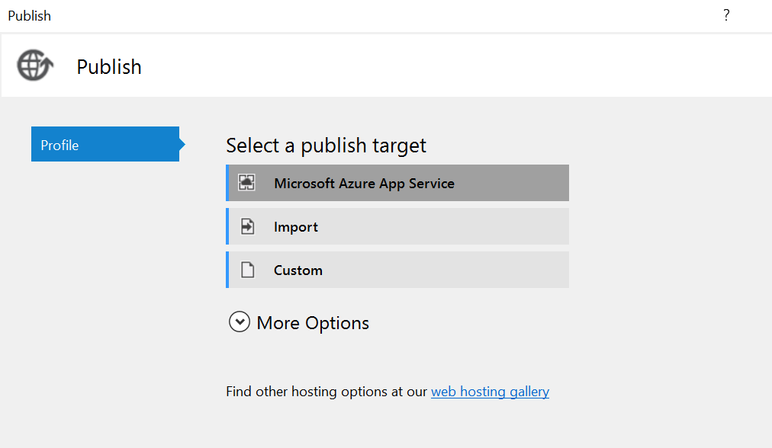

* Select Resource Group and Web App which you created on Azure Portal.

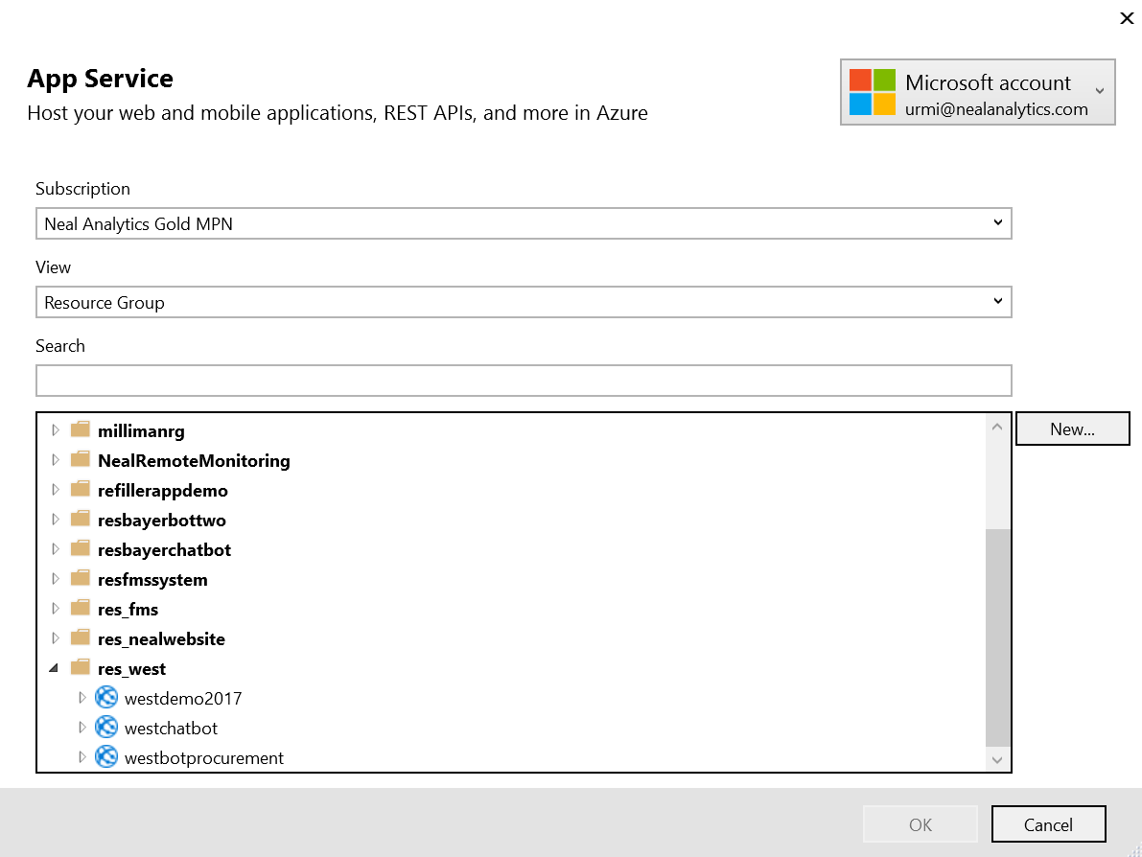

* Now it generates password and after validating it Publish it.

